

Requirements Specification
Project Name: Vehicle Insurance Management System
Project ID: 1105
System Analysts: Tenti Morobe, Jubilant Motlhake,Kaelo , Lindani ,Siphamandla , Mpho and Simo

Date: 26 May 2022
Table of Contents
1 Introduction 4
1.1 Project Purpose 4
1.2 Project Scope and Product Features 4
1.3 Out of Scope 5
1.4 Project Acronyms, Abbreviations and Terms 5
1.5 Stakeholders 5
2 Design Requirements 6
2.1 User Classes and Characteristics 6
2.2 Operating Environment (OE) 7
2.3 User / Training Documentation 7
2.4 Globalization / Localization Requirements (GR) 7
2.5 Assumptions (AS) 7
2.6 Dependencies (DE) 7
Usage Scenario(s) 8
2.7 User Story 9
3 Functional Requirements 11
4 Other Nonfunctional Requirements 12
4.1 Security Requirements (SE) 12
4.2 Regulatory and Compliance Requirements (RE), (CP) 12
4.3 Other Data Storage, Archival, Back-up, Recover and Destruction (STR) 13
5 System Diagrams 13
5.1 System Sequence Diagram (SSD) 13
5.2 Entity-relationship Model (ERD) 13
5.3 Data Flow Diagram (DFD) 13
6 Glossary 14
7 Appendix 14
7.1 Reference 14
7.1.1 14

Revision History

Version | Date | Revision Description
.01 | 27/05/2022 | Draft Version
.02

Introduction

Project Purpose

This is a Requirements Specification document for Liberty Finance's automobile insurance management system. Liberty Finance is a financial services and property investment firm. The new system will make it simple for managers to store client-insured vehicles. The technology will assist the company in being more successful, efficient, and data retrievable. The scope, aims, and goal of the new system are described in this document. This document also includes use cases, user stories, ERDs, System sequence diagrams, and DFD diagrams to model the functional requirements for the system.aphs.

Project Scope and Product Features

The vehicle insurance management System will provide multiple online management functionality that handle data and information pertaining to vehicle insurance. The system will only have one main part, the web-based application management system.

Product Features:
The System will make use of the internet because it is web based and constantly need to be online to operate efficiently. All the information saved will be stored on the SQL database which is located on the Microsoft azure. The system does not allow for offline functionality.

The product features for the different parts of the system are as follows:
- Secure Login and Logout
- Dashboard
  - Display the summary of lists.
- Categories Management
  - Add New Category
  - List All Categories
  - View Category
  - Update Category
  - Delete Category
- Insurance Policy Management
  - Add New Insurance Policy
  - List All Insurance Policies
  - View Insurance Policy Details
  - Update Insurance Policy Details
  - Delete Insurance Policy Details
- Client Management
  - Add New Client
  - List All Clients
  - Update Client Details
  - View Client Details
  - List all Client's Insured Vehicles
  - Delete Client Details
- Vehicle Insurance Management
  - Add New Insurance
  - List All Insurances
  - Update Insurance Details
  - View Insurance Details
  - Print Insurance Details
  - Delete Insurance Details
- Generate Reports
  - Printable Date-wise Transaction Report
- Manage User List (CRUD)
- Manage Account Details/Credentials
- Manage System Information

Out of Scope

- The cloud service provider will not change
- The cloud services and web address will not change
- The IT infrastructure will not change
- The project will affect web-based platforms only; all other platforms are out of scope

Project Acronyms, Abbreviations and Terms

Term | Description
ERD | Entity relationship diagram
DFD | Data Flow Diagram
SSD | System Sequence Diagram
UI | User Interface

Stakeholders

Name and Surname | Responsibility | Role
Neo Mponya | Project Owner | Facilitator
Nomathamsanqa Ntuli | Project Sponsor | Consultant

Design Requirements

User Classes and Characteristics

User Class Name | Critical (Y/N) | How They Use the System
Employee | Y | Use the system to view, delete, edit client information.
Employee | Y | Use the system to Use the system to view, delete, edit insurances.
Employee | Y | Use the system to Use the system to view, delete, edit policies
Employee | Y | Use the system to filter and print reports.
Employee | Y | Use the system to Use the system to view, delete, edit category information.
Employee | Y | Manage Admin account
Administrator | Y | Use the system to create new clients
Administrator | Y | Use the system to view, delete, edit client information.
Administrator | Y | Use the system to add new insurances
Administrator | Y | Use the system to use the system to view, delete, edit insurances
Administrator | Y | Use the system to add new policies
Administrator | Y | Use the system to use the system to view, delete, edit policies
Administrator | Y | Use the system to filter and print reports
Administrator | Y | Use the system to add new category
Administrator | Y | Use the system to Use the system to view, delete, edit category information.
Administrator | Y | Use the system to edit and delete user information.
Administrator | Y | Use the system to add a new user
Administrator | Y | Update system information
Administrator | Y | Manage Admin account

Operating Environment (OE)

Number |  | Requirement
OE | 1 | The application will be deployed on the Microsoft Azure

User / Training Documentation

Name | Description and Format
User Manual | The user manual describes how a user can use the system

Globalization / Localization Requirements (GR)

Number |  | Requirement
GR | 1 | Local – English speakers
GR | 2 | Local – South African Market

Assumptions (AS)

Number |  | Assumption
AS | 1 | The infrastructure is based in cloud computing
AS | 2 | The infrastructure uses Microsoft Azure
AS | 3 | Users are employees

Dependencies (DE)

Number |  | Dependency
DE | 1 | Microsoft Azure platform
DE | 2 | SQL Database

Usage Scenario(s)
The following use case shows how users interact with the system
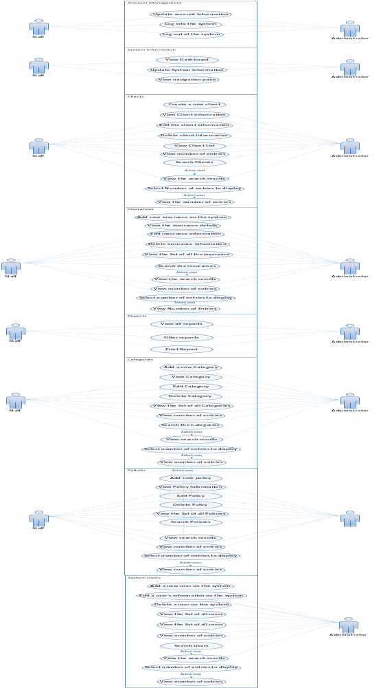
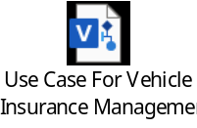

User Story
The following user story describes how the staff and administrator use the system

Vehicle Insurance Management System | User Story (Staff)
Dashboard | As a staff member, I can view the dashboard
Client List | As a staff member, I can view, edit and delete clients in the system
Client List | As a staff member, I can search for different clients in the system
Client List | As a staff member, I can view a list of clients in the system with a brief summary of each
Insurance list | As a staff member, I can search for different insurances in the system
Insurance list | As a staff member, I can view, edit and delete insurance files in the system
Insurance list | As a staff member, I can view the list of insurances with a brief summary of each.
Reports | As a staff member, I can print and filter reports based on the dates
Reports | As a staff member, I can view the list of all reports in the system with a brief summary of each
Category List | As a staff member, I can view, edit and delete categories
Category List | As a staff member, I can search for different categories in the system
Category List | As a staff member, I can view the list of all categories with a brief summary of each.
Policies List | As a staff member, I can view, edit and delete policies
Policies List | As a staff member, I can search for different policies in the system
Policies List | As a staff member, I can view the list of all categories with a brief summary of each.
Account manager | As a staff member, I can update my personal information and passwords
Account manager | As a staff member, I can Log in and log out of the system
Navigation | As a staff member, I can select how many entities I want to display.
Navigation | As a staff member, I can navigate between pages

Vehicle Insurance Management System | User Story (Administrator)
Dashboard | As an administrator, I can view the dashboard
Client List | As an administrator, I can add a new client
Client List | As an administrator, I can view, edit and delete clients in the system
Client List | As an administrator, I can search for different clients in the system
Client List | As an administrator, I can view a list of clients in the system with a brief summary of each
Insurances | As an administrator, I can add a new insurance in the system
Insurances | As an administrator, I can search for different insurances in the system
Insurances | As an administrator, I can add a new insurance in the system
Insurances | As an administrator, I can view, edit and delete insurance files in the system
Insurances | As an administrator, I can view the list of insurances with a brief summary of each.
Reports | As an administrator, I can print and filter reports based on the dates
Reports | As an administrator, I can view the list of all reports in the system with a brief summary of each
Category List | As an administrator, I can add a new category
Category List | As an administrator, I can view, edit and delete categories
Category List | As an administrator, I can search for different categories in the system
Category List | As an administrator, I can view the list of all categories with a brief summary of each.
Policies List | As an administrator, I can add a new policy in the system
Policies List | As an administrator, I can view, edit and delete policies
Policies List | As an administrator, I can search for different policies in the system
Policies List | As an administrator, I can view the list of all categories with a brief summary of each.
User List | As an administrator, I can create a new user
User List | As an administrator, I can view, update and delete the user’s information.
User List | As an administrator, I can search for different users in the system.
User List | As an administrator, I can view the list of all users in the system with a brief summary of each user.
Setting | As an administrator, I can update system information such as the system name, system cover, system logo and the system short name
Account manager | As an administrator, I can update my personal information and passwords
Account manager | As an administrator, I can Log in and Log out of the system
Navigation | As an administrator, I can select how many entities do I want to display
Navigation | As an administrator, I can navigate between pages

Functional Requirements

Functional Requirements | Functional Requirement Name | Requirement Description
FR1 | Add new users | The system should allow for new users to be added
FR2 | Existing users’ information | Users' information should be able to be viewed, edited, and deleted through the system.
FR3 | Generate Reports | The system should allow for generation of date-wise transaction reports
FR4 | Add Insurances | The system should allow for addition of new insurances
FR5 | Insurance details | The system should allow for the viewing, editing, and deletion of insurance information.
FR6 | Add new policy | The system should allow addition of new policy
FR7 | Policy details | Viewing, updating, and deleting policy information should all be possible through the system.
FR8 | Search option | The system should provide a search function that allows users to look for information to which they have access.
FR9 | Manage Accounts | Users should be able to manage their accounts, including altering user information, passwords, usernames, and adding avatars.
FR10 | Add categories | The system should allow addition of new category
FR11 | Category details | Viewing, updating, and deleting category information should all be possible through the system.
FR12 | Navigation Pane | The system should allow for users to select the number of entries to display.

Other Nonfunctional Requirements

Security Requirements (SE)

Number |  | Requirement
SE | 1 | The system must protect personal details
SE | 2 | The system must protect insurance information
SE | 3 | The system must protect policy information
SE | 4 | Secure log in/out

Regulatory and Compliance Requirements (RE), (CP)

Number |  | Requirement
RE | 1 | Compliance of the POPI Act (Protection of personal information)
CP | 1 | Compliance of the Consumer Protection Act

Other Data Storage, Archival, Back-up, Recover and Destruction (STR)

Number |  | Requirement
STR | 1 | Microsoft Services provides data storage and recovery

System Diagrams

System Sequence Diagram (SSD)
The following diagram shows how the functions and use case functions are performed inside the system.

Entity-relationship Model (ERD)
The following diagram shows the relationship of entity sets in the database.
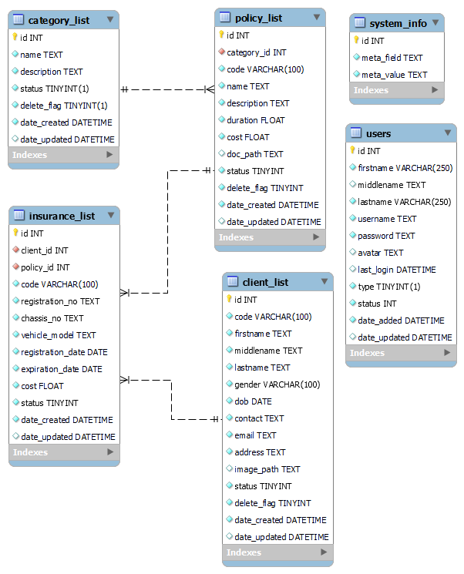
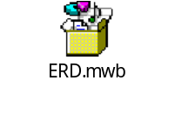

Data Flow Diagram (DFD)
The flow of data through the car insurance management system is illustrated in the diagram below.
The diagram is flow of data for the user ( Administrator)
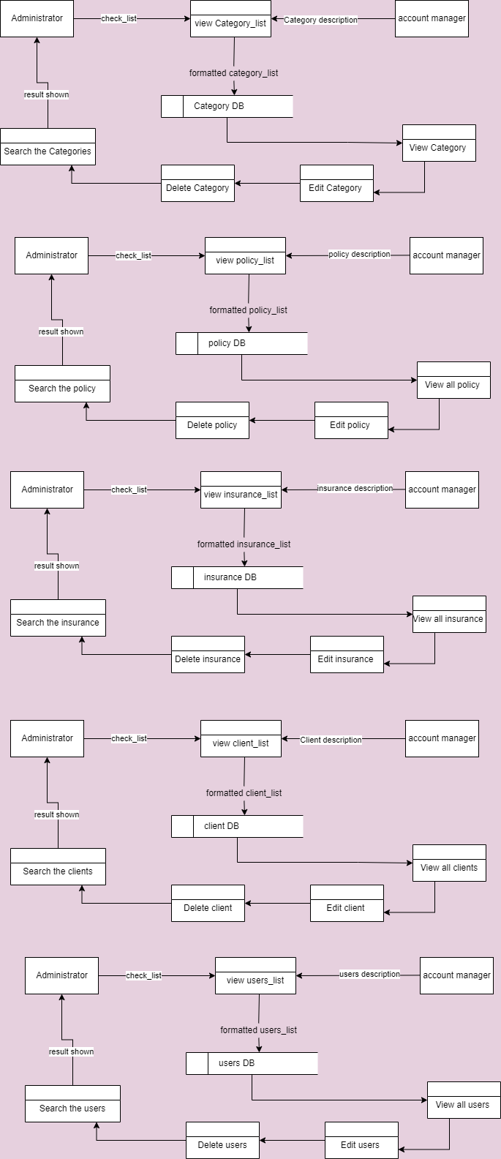

Glossary

Term | Definition
User | A user is a person who utilise a computer or network services
Administrator | An administrator is in charge of maintaining, configuring, and ensuring the reliable operation of computer systems, servers, and data security measures.
Client | A client is a person or company who pays for a professional person or organization to provide them with a service.
Insurance | Insurance is a contract in which an individual or entity receives financial protection or compensation from an insurance provider in the event of a loss, which is represented by a policy.
Policy | A collection of ideas or a plan for dealing with specific conditions that has been publicly agreed to by a group of individuals, a commercial organization, the government, or a political party.

Appendix

Reference

Bandakkanavar, R. (2019, October 17). Software Requirements Specification document with example. Krazytech. https://krazytech.com/projects/sample-software-requirements-specificationsrs-report-airline-database
Editor. (2020, February 12). Non-functional Requirements: Examples, Types, How to Approach. AltexSoft. https://www.altexsoft.com/blog/non-functional-requirements/
A Guide to Functional Requirements (with Examples). (n.d.). Nuclino. Retrieved May 26, 2022, from https://www.nuclino.com/articles/functional-requirements
What is Data Flow Diagram (DFD)? How to Draw DFD?. Visual-Paradigm. Retrieved May 28, 2022 from
What is Data Flow Diagram (DFD)? How to Draw DFD? (visual-paradigm.com)
Microsoft. (n.d.). Create a UML use case diagram. Retrieved May 26, 2022, from
https://support.microsoft.com/en-us/office/create-a-uml-use-case-diagram-92cc948d-fc74-466c-9457-e82d62ee1298
R. (2020, July 28). Functional vs Non-Functional Requirements - Understand the Difference. ReQtest. https://reqtest.com/requirements-blog/functional-vs-non-functional-requirements/

